WBP Coastal Ecosystem Group Meeting 7, 24th April 2012, Kenfig National Nature Reserve

Present: Peter Rhind Chair (CCW); Emmer Litt (CCW); Mike Howe (CCW); Duncan Ludlow (CCW); Angus Garbutt (CEH); Sean McHugh (WBP); Beth Henshall (WEL); Steve Chambers (WG-SEED); David Carrington (Bridgend CBC); Becky Sharp (Neath Port Talbot CBC); Elen Richards (Neath Port Talbot CBC); Mark Winder (Swansea City & Council); Kate Collins (EAW); Jill Howells (EAW)

Field Trip: All the above attended & Geoff Hobbs (Bridgend CBC); CCW regional staff Ceri Seaton and Nicky Rimington

Apologies: Julie Bowes (WG-SEED); Matty Murphy (CCW); Jane Hodges (Pembrokeshire Coast NPA); Chris Wynne (Wildlife Trusts Wales); Richard Ellis (National Trust)

A short meeting was held in the morning; the main focus was a field visit to see at first hand the sand dune habitat restoration work at Kenfig.
No. | Actions | Who | By | Comments
1 | Monitoring of coastal ERDC projects | Steve Chambers to discuss with SEED colleagues | Next meeting | Need a baseline for monitoring of practical works. Peter has secured a small amount of CCW funds to begin monitoring efforts at Kenfig.
2 | Future Projects includ. ERDC & EW projects | ALL (send to Peter Rhind cc San McHugh) | ASAP | Need an inventory of projects both large & small for the CEG to support & action
3 | CEG Priorities | Peter & Mike to look at CEG priorities and send to group for consultation | Next meeting | This will stimulate the flow of projects for potential funding
4 | Ecology of beach nourishment report | Emmer Litt | Next meeting | 10 sites investigated for ecological impact of beach nourishment
5 | Wales Coast Path Launch | ALL | For information | Opens 5th May. 870 miles in length. Good potential to highlight coastal ecosystems to a wide audience
6 | Sand dune Workshop Proceedings to be made available | Peter Rhind | Next meeting | International meeting held at Kenfig, Sept 2011
7 | Baglan Burrows potential development. CEG Chair needs to discuss with local CCW staff & organise surveys/comment on LDP Deposit. Also needs to be raised at a high level in CCW, potentially to Council | Peter Rhind/Mike Howe | ASAP | NPT Ecology staff concerned about the potential loss of dunes & coastal squeeze if development proceeds & have articulated this to local CCW staff.
Previous Actions update
 | Managed retreat site update | Kate to contact Halyn Williams | Issues around confidentially. A GIS study is available & can be presented to CEG
 | Coastal Shingle Priority Map | Peter Rhind | On-going
 | Maritime Cliff survey | Peter Rhind | On-going
 | Monitoring of nearshore chemical & physical water attributes | Emmer Litt | On-going | Will influence marine EG & will assist with long-term monitoring efforts
 | Presenting progress of Ecosystem Groups | Mike Howe | On-going | Mike spoke with Jan-grasslands EG are conducting workshops to translate national action to local & is a model CEG could follow.
 | Saltmarsh & Mudflat Report | Emmer Litt | On-going | EA saltmarsh survey (extent) available on request. CCW survey is focussing on coastal squeeze effects of species on wave-cut platforms. Emmer will check if other reports exist.
 | Glastir monitoring coastal research | Peter Rhind | On-going | Highlight need for research. Saltmarsh holds significant amounts of CO2 in addition to ecological importance.

Sand Dune Workshop
Sand dunes identified as a CEG priority. A high-level workshop was held at Kenfig in September 2011 bringing together local, national and international experiences in sand dune management including Ken Pye, a World authority on sand dune rejuvenation. Priorities: Understand processes; follow expert advice; engage stakeholders; dune over stabilisation=ecological shortfall.
Ecosystem Resilience, Diversity & Compliance Fund
Project funds (£1 million) were made available by Welsh Government and the coastal EG successfully bid for 70k to fund 10 surveys on some of the larger sand dune sites in Wales, and for practical work at Kenfig - creating habitats for fen orchid and sand dune rejuvenation to create pioneer dune conditions.
Kenfig Sand Dune Work
As advised by Ken Pye, the sand dune rejuvenation took place close to coastal front and in an area of above average wind strength for the site. 3.6Ha of mature dune stripped of vegetation by diggers in February 2011. As the lead in time for the project was short, it would have been more ideal to begin the work earlier in the winter & over a larger area. The stripped vegetation was banked in an ‘arm’ at right angles to the coast line. Likely that ERD funds will continue 2012/13 and the rejuvenation work can be extended in area at Kenfig and to other sites in Wales.
In addition, 4 half acre dune slacks created and 110 ponds- the low winter rainfall is giving some cause for concern as the water table is low.
The works represent a partnership between CCW, Plantlife , Bridgend CBC and the Trustees of Kenfig with the support of WBP CEG & Welsh Government. Well received to date, the project featured on the Radio 4 ‘Costing the Earth programme’. The work was funded by the Ecosystem Resilience, Diversity & Compliance fund. Environment Wales Funding (15k) contributed to earlier dune slack creation work at Kenfig. 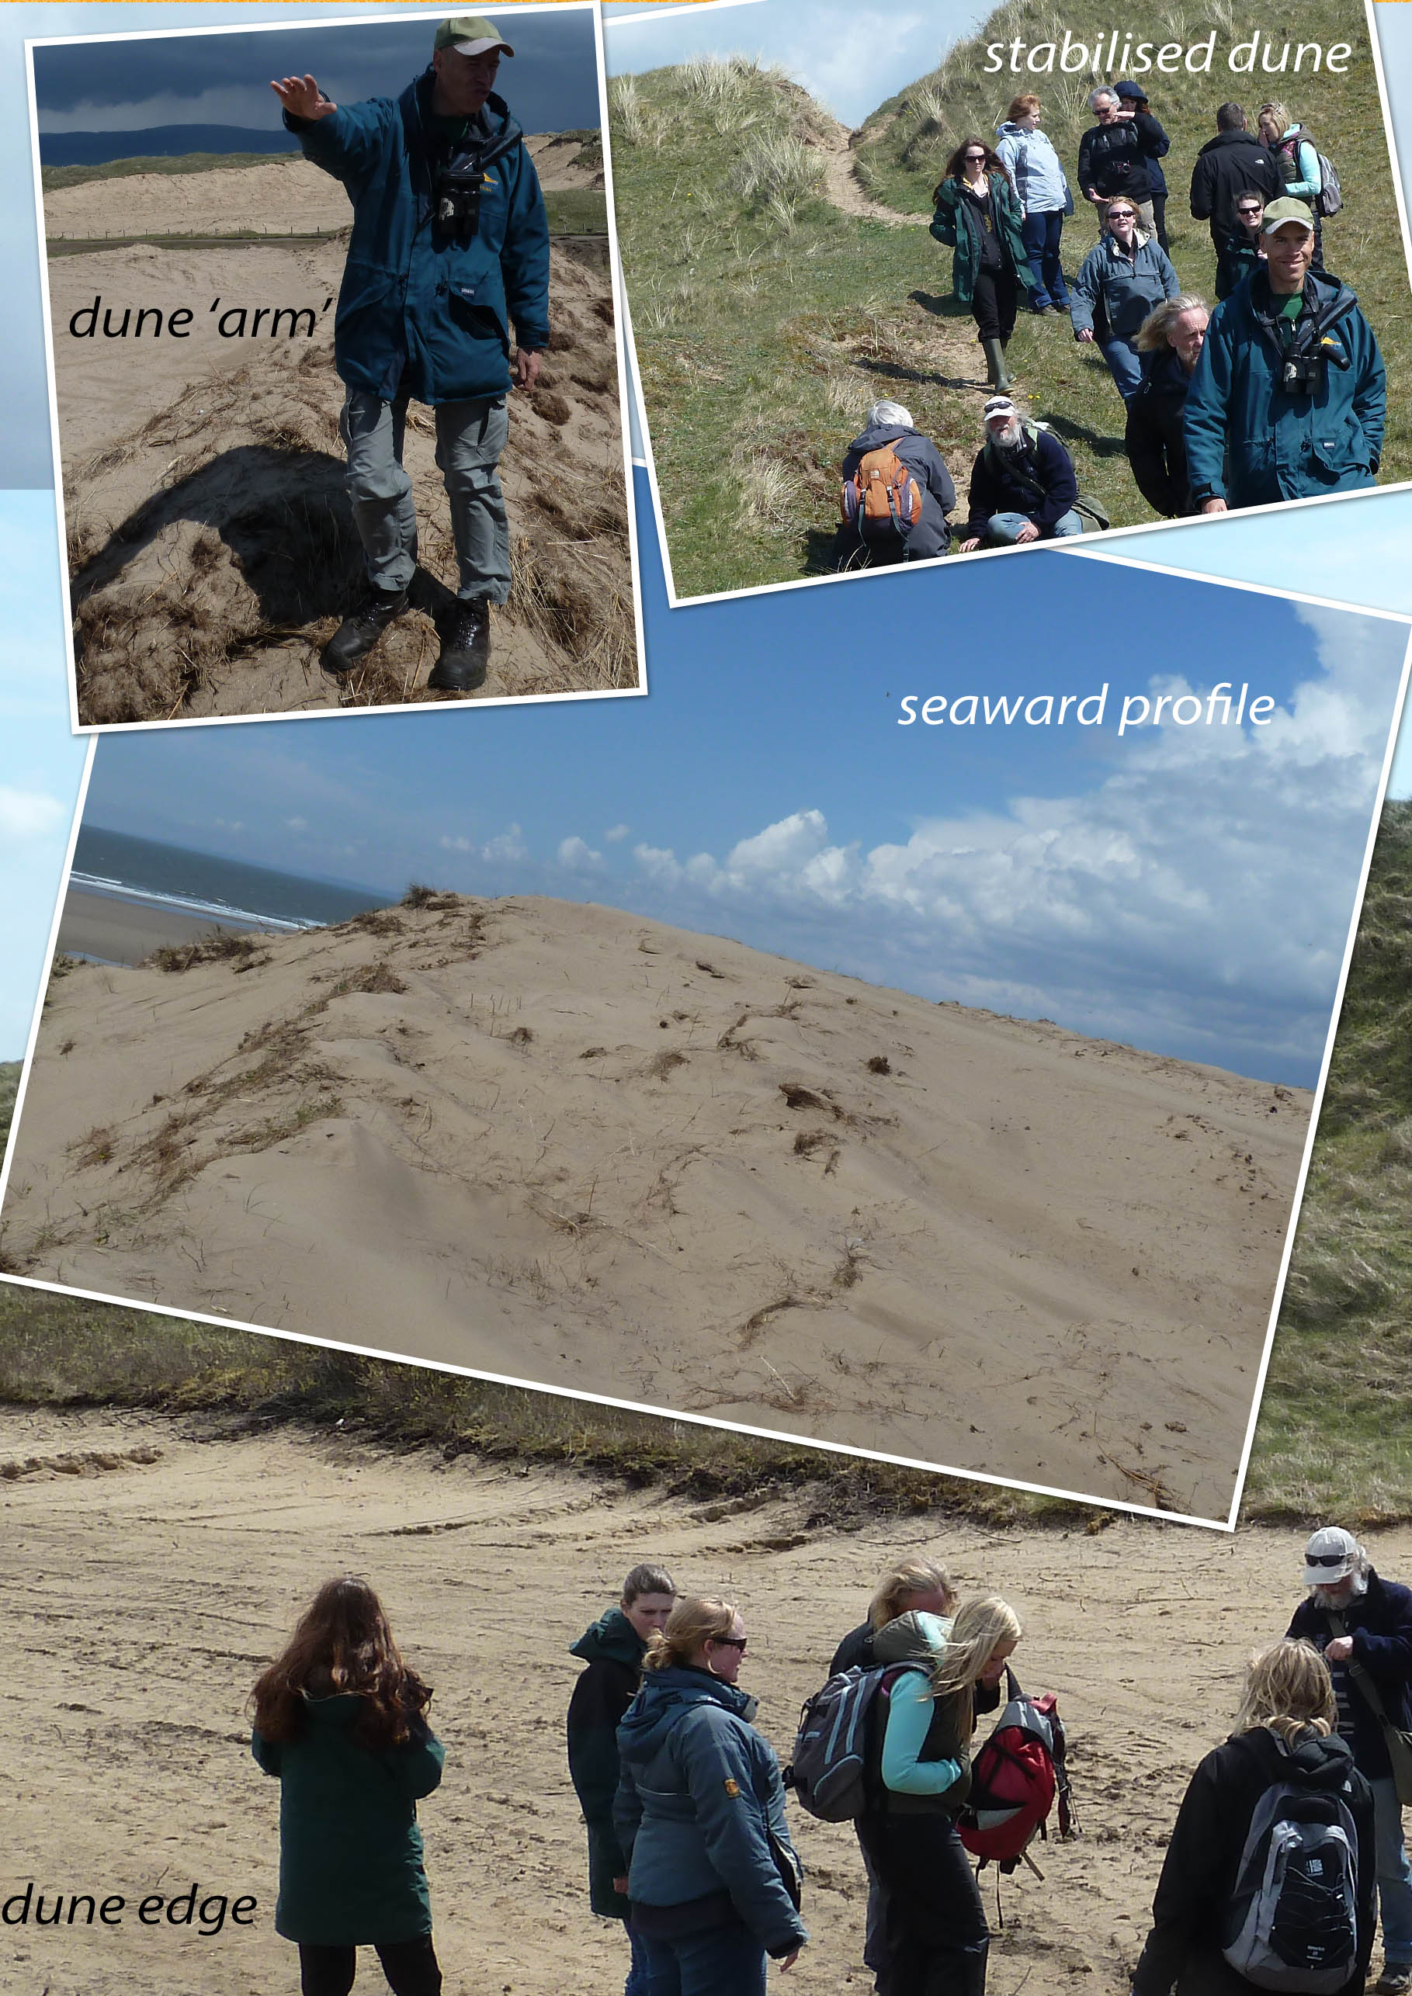
Fig 1. Overview of dune rejuvination work at Kenfig. Note the vegetated dune (stabilised) and the bare sand exposed in the 3 ‘rejuvinated’ dune images. The linear ridge ‘dune arm’ runs parallel to the direction of Dave’s arm and was sourced from stripped vegetation removed from nearby stabilised dunes leaving bare sand exposed.

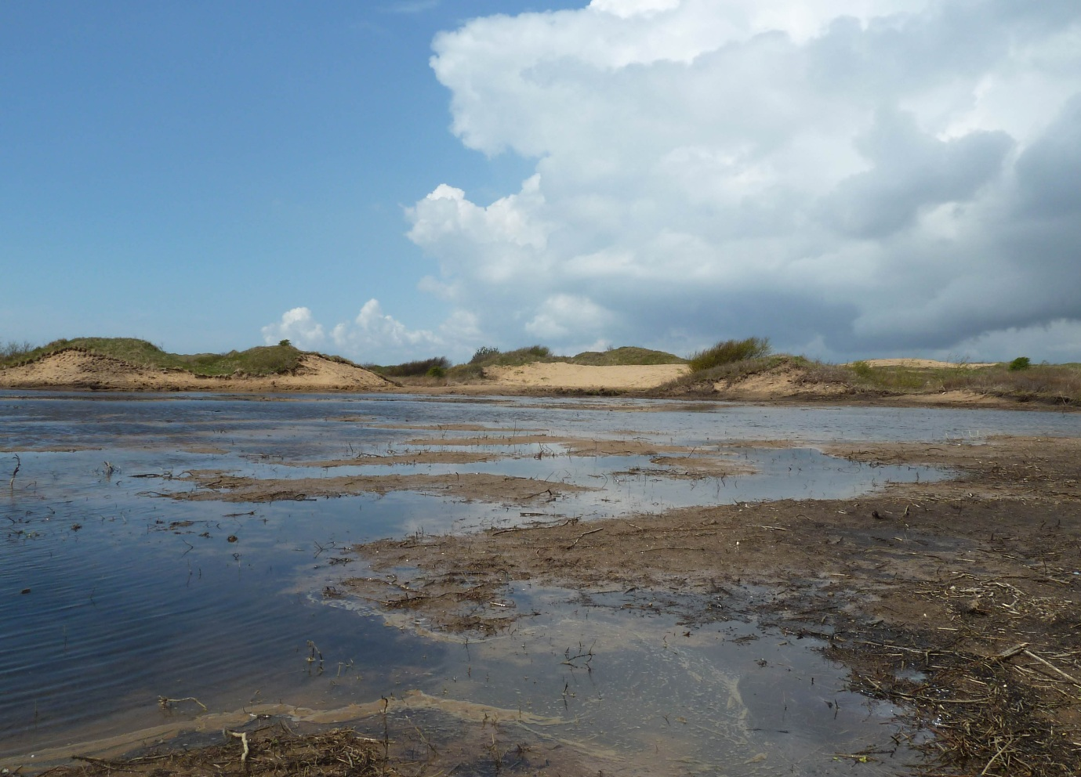
Fig 2. Dune slack created by mechanical scraping at Kenfig. for. The newly created slack will benefit fen orchid and many other species. Manual intervention has been necessarry due to the stabilisation over the years of the Kenfig dunes. Fen orchid is one of the rarest plants in the UK and is known from only 2 locations, south Wales and the Norfolk Broads. Kenfig is the stronghold with around 90% of the UK population.

